**Topics: Normal distribution, Functions of Random Variables**

1. The time required for servicing transmissions is normally distributed with *μ* = 45 minutes and *σ* = 8 minutes. The service manager plans to have work begin on the transmission of a customer’s car 10 minutes after the car is dropped off and the customer is told that the car will be ready within 1 hour from drop-off. What is the probability that the service manager cannot meet his commitment?
2. 0.3875
3. 0.2676
4. 0.5
5. 0.6987

Ans. Option b 0.2676

round(1-stats.norm.cdf(60,loc=55,scale=8),5)

1. The current age (in years) of 400 clerical employees at an insurance claims processing center is normally distributed with mean *μ* = 38 and Standard deviation *σ* =6. For each statement below, please specify True/False. If false, briefly explain why.

N=400

*μ* = 38

*σ* =6

1. More employees at the processing center are older than 44 than between 38 and 44.

The above statement is False. Here we can see that the probability of getting a person above the age of 44 is less than the probability of getting a employees whose age lies between 38 and 44.

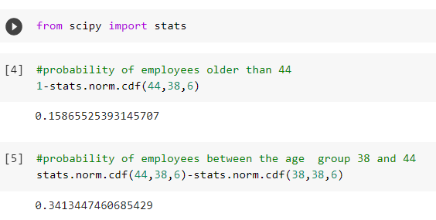

1. A training program for employees under the age of 30 at the center would be expected to attract about 36 employees.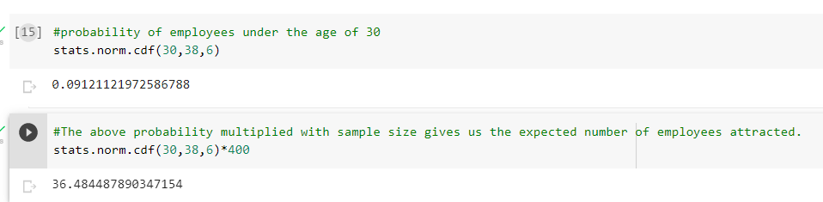

True.

1. If *X1* ~ *N*(μ, σ2) and *X*2 ~ *N*(μ, σ2) are *iid* normal random variables, then what is the difference between 2 *X*1 and *X*1 + *X*2? Discuss both their distributions and parameters.

CASE 1. Here 2 *X*1 =X1+X1

The Sum of 2 normally Distributed data will also follows normal distribution with mean =sum of corresponding mean (mean1+mean1) and standard deviation =sum of corresponding standard deviation.

CASE 2. Here in case of X1+X2 both are iid or independent and identically distributed.

The sum of these distribution will also be a normal distribution. And the mean of the new distribution will be the sum of corresponding distribution

Mean=( μ1+ μ2)

Standard deviation=( σ21+ σ22)

If μ1= μ2 and σ21= σ22 this is now similar to the case1

1. Let X ~ N(100, 202). Find two values, *a* and *b*, symmetric about the mean, such that the probability of the random variable taking a value between them is 0.99.
2. 90.5, 105.9
3. 80.2, 119.8
4. 22, 78
5. 48.5, 151.5
6. 90.1, 109.9

ANS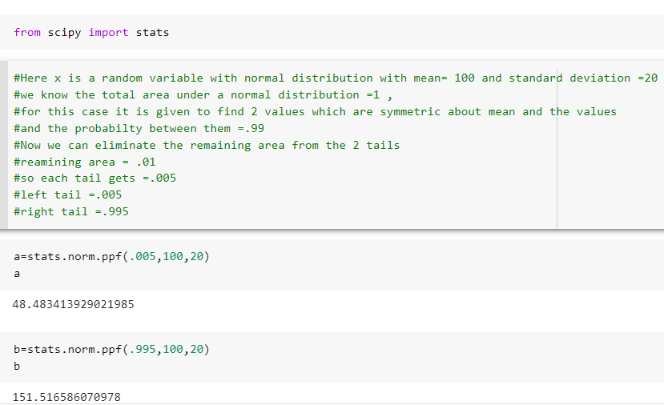

1. Consider a company that has two different divisions. The annual profits from the two divisions are independent and have distributions Profit1 ~ N(5, 32) and Profit2 ~ N(7, 42) respectively. Both the profits are in $ Million. Answer the following questions about the total profit of the company in Rupees. Assume that $1 = Rs. 45

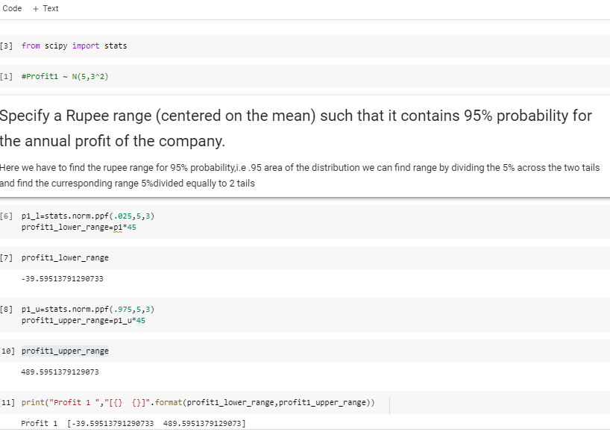

Profit 1 [-39.59513791290733 489.5951379129073]

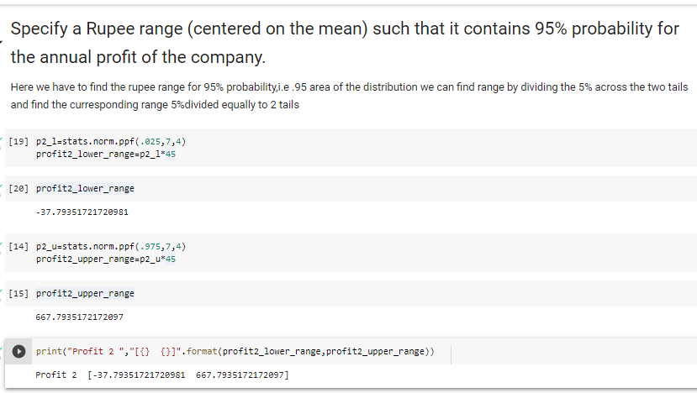

Profit 2= [-37.79351721720981 667.7935172172097]

Total profit range is given buy add the 2

[-77.3887 1157.3887] This profit range is in millions

1. Specify the 5th percentile of profit (in Rupees) for the company?

Profit 1

Here we can find the 5th percentile using the equation

**Percentile Value = μ + zσ**

**Z=-1.65**

**σ =3**

**μ = 5**

**percentile =.05, .05*45=2.25 million rupees**

profit 2

Here we can find the 5th percentile using the equation

**Percentile Value = μ + zσ**

**Z=-1.65**

**σ =4**

**μ = 7**

**percentile =.4, .4*45=18 million rupees**

Total

18+2.25 =20.25 million rupees

1. Which of the two divisions has a larger probability of making a loss in a given year?

